***DSA LAB ASSIGNMENT = 3***

Name :- Ankit Senjaliya

Enrollment No. :- 19BT04046

(5) Write a C/C++ program to implement following searching algorithms :-

1. Linear Search :

#include<iostream.h>

#include<conio.h>

//using namespace std;

void linearSearch(int a[], int n)

{

int temp = -1;

for(int i=0;i<10;i++)

{

if(a[i] == n)

{

cout<<"\n Element Found At Position = " <<i + 1<<endl;

temp = 0;

break;

}

}

if(temp == -1)

{

cout<<"\n No Element Found" <<endl;

}

}

int main()

{

clrscr();

int arr[5];

cout<<"\n Please Enter 10 Element Of The Array = "<< endl;

for(int i=0;i<10;i++)

{

cin >> arr[i];

}

cout<<"\n Please Enter An Element To Search = "<< endl;

int num;

cin >> num;

linearSearch(arr,num);

getch();

return 0;

}

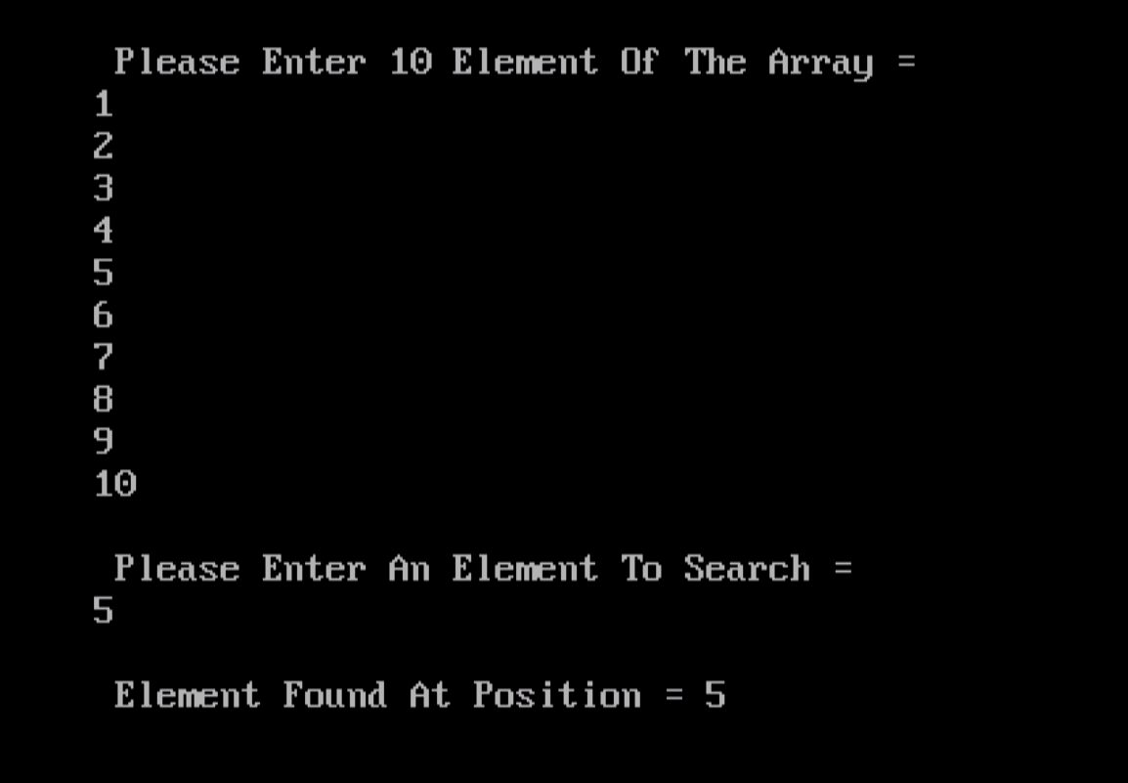

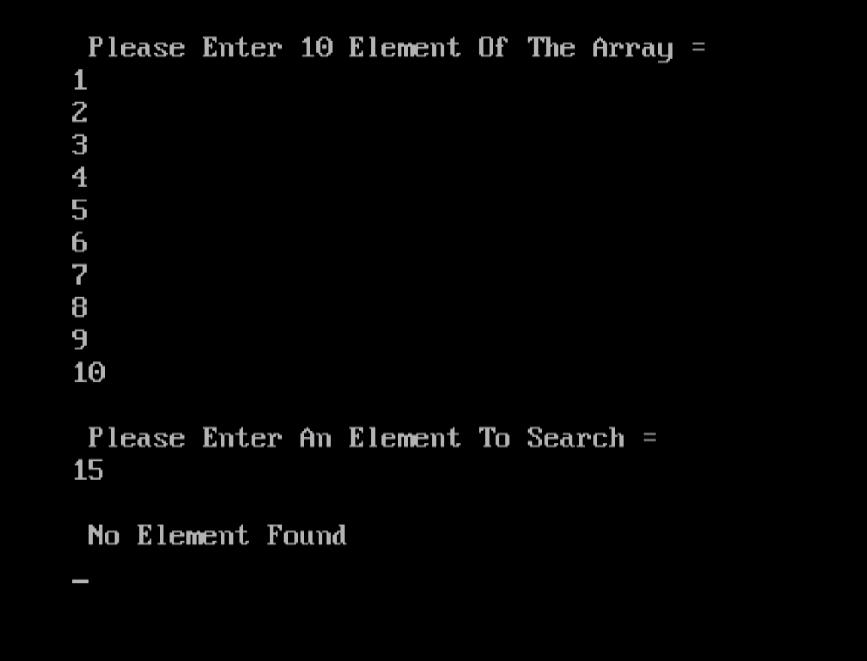

1. Binary Search :-

#include<iostream.h>

#include<conio.h>

//using namespace std;

int binarySearch(int arr[], int left, int right, int x)

{

while(left <= right)

{

int mid = left + (right - left)/2;

if(arr[mid] == x)

{

return mid;

}

else if(arr[mid] < x)

{

left = mid + 1;

}

else

{

right = mid - 1;

}

}

return -1;

}

int main()

{

clrscr();

int myarr[12];

int num;

int output;

cout<<"\n Please Enter 12 Elements ASCENDING order = " <<endl;

for(int i=0;i<12;i++)

{

cin>>myarr[i];

}

cout<<"\n Please Enter An Element To Search = " <<endl;

cin>>num;

output = binarySearch(myarr, 0, 11, num);

if(output == -1)

{

cout<<"\n No Match Found "<<endl;

}

else

{

cout<<"\n Match Found At Position = "<<output<<endl;

}

getch();

return 0;

}

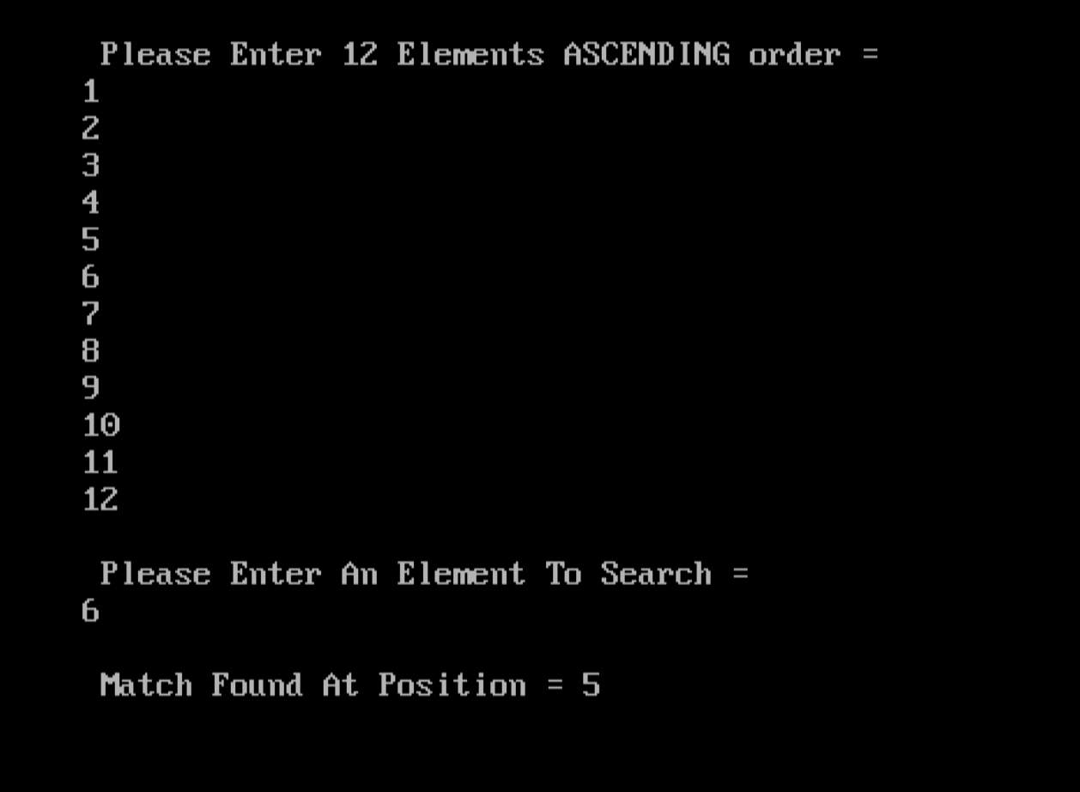

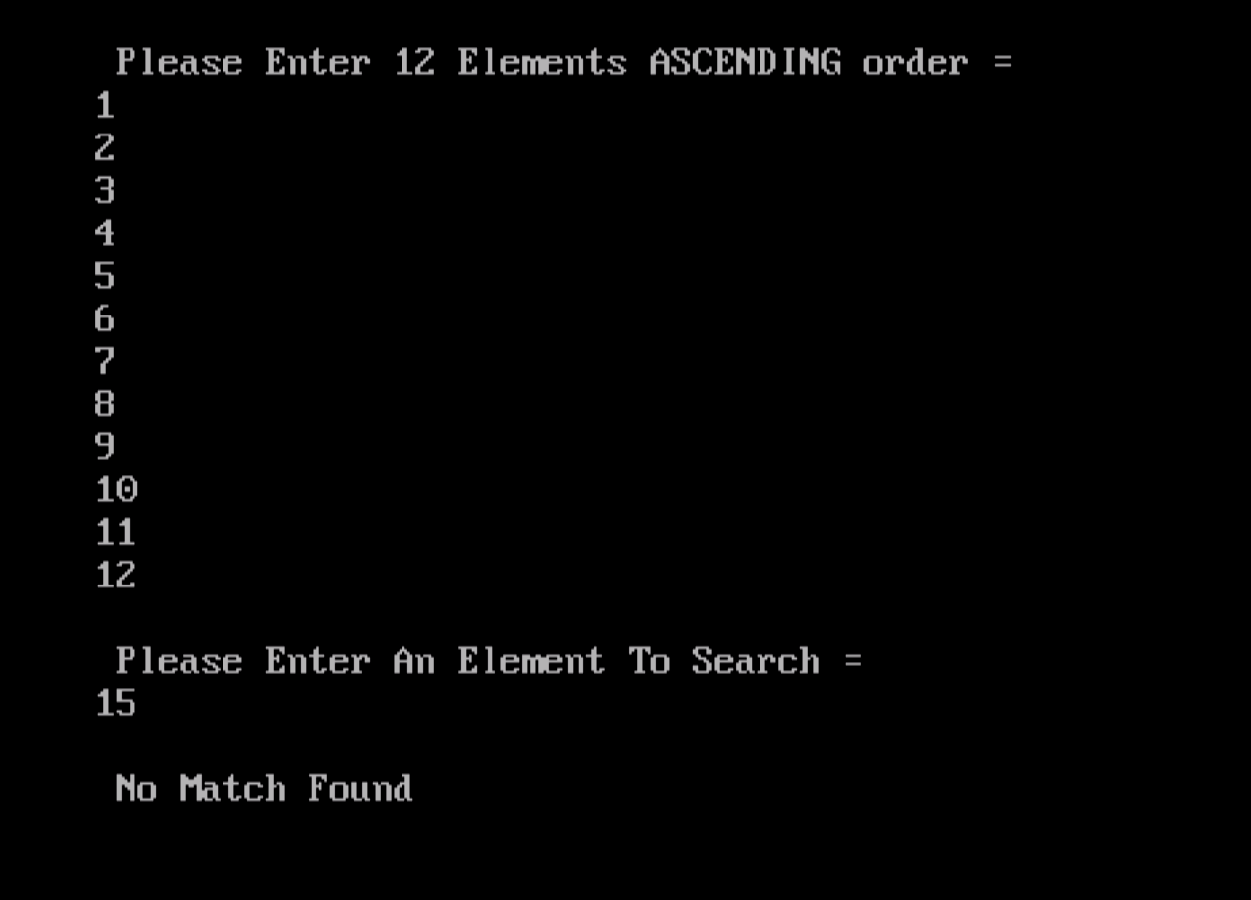

(6) Write C/C++ programs for implementing the following sorting method:-

1. Quick Sort :

#include<iostream.h>

#include<conio.h>

//using namespace std;

void swap(int* a,int* b)

{

int t = *a;

*a = *b;

*b = t;

}

int partition (int arr[], int low, int high)

{

int pivot = arr[high];

int i = (low - 1);

for(int j = low; j <= high - 1; j++)

{

if(arr[j] <= pivot)

{

i++;

swap(&arr[i], &arr[j]);

}

}

swap(&arr[i + 1], &arr[high]);

return (i+1);

}

void quicksort(int arr[], int low, int high)

{

if(low < high)

{

int pivot = partition(arr, low, high);

quicksort(arr, low, pivot - 1);

quicksort(arr, pivot + 1, high);

}

}

void displayArray(int arr[], int size)

{

int i;

for(i=0;i<size;i++)

cout<<" "<<arr[i];

}

int main()

{

clrscr();

int arr[] = {15,7,33,28,40,11,68,22};

int n = sizeof(arr)/sizeof(arr[0]);

cout<<"\n Enter Array = "<<endl;

displayArray(arr,n);

cout<<endl;

quicksort(arr, 0, n-1);

cout<<"\n Array Sorted With Quick Sort = \n "<<endl;

displayArray(arr,n);

getch();

return 0;

}

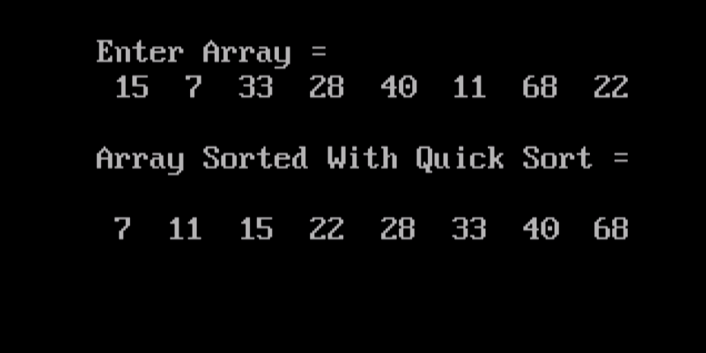

1. Merge SORT :

#include<iostream.h>

#include<conio.h>

// using namespace std;

void merge(int*,int,int,int);

void mergesort(int *a,int low,int high)

{

int mid;

if(low < high)

{

mid = (low + high)/2;

mergesort(a,low,mid);

mergesort(a,mid + 1,high);

merge(a,low,high,mid);

}

return;

}

void merge(int *a,int low,int high,int mid)

{

int i,j,p,d[35];

i = low;

j = mid + 1;

p = low;

while(i<=mid && j<=high)

{

if(a[i]<a[j])

{

d[p] = a[i];

p++;

i++;

}

else

{

d[p] = a[j];

p++;

j++;

}

}

while(i<=mid)

{

d[p] = a[i];

p++;

i++;

}

while(j<=high)

{

d[p] = a[j];

p++;

j++;

}

for(i=low;i<p;i++)

{

a[i] = d[i];

}

}

int main()

{

clrscr();

int b[35],i,c[35];

cout<<"\n Enter The Number Of Element = \n ";

for(i=0;i<=7;i++)

{

cin>>b[i];

}

mergesort(b,0,7);

cout<<"\n Sorted Array = \n "<<endl;

for(i=0;i<8;i++)

{

cout<<" "<<b[i];

}

getch();

return 0;

}

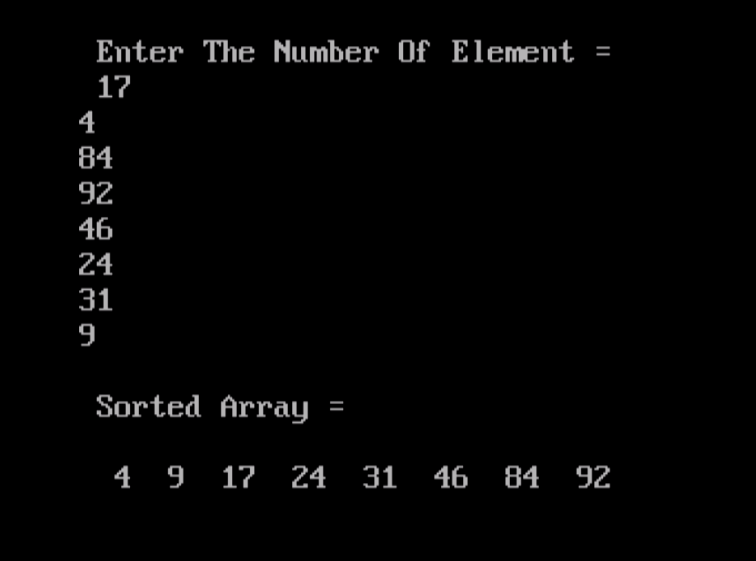

1. Bubble Sort :

#include<iostream.h>

#include<conio.h>

//using namespace std;

int main()

{

clrscr();

int a[50],n,i,j,temp;

cout<<"\n Enter The Size Of Array = "<<" ";

cin>>n;

cout<<"\n Enter The Array Element = \n "<<endl;

for(i=0;i<n;i++)

cin>>a[i];

for(i=1;i<n;i++)

{

for(j=0;j<(n-i);j++)

if(a[j]>a[j+1])

{

temp = a[j];

a[j] = a[j+1];

a[j+1] = temp;

}

}

cout<<"\n Array After Bubble Sort = \n "<<endl;

for(i=0;i<n;i++)

cout<<" "<<a[i];

getch();

return 0;

}

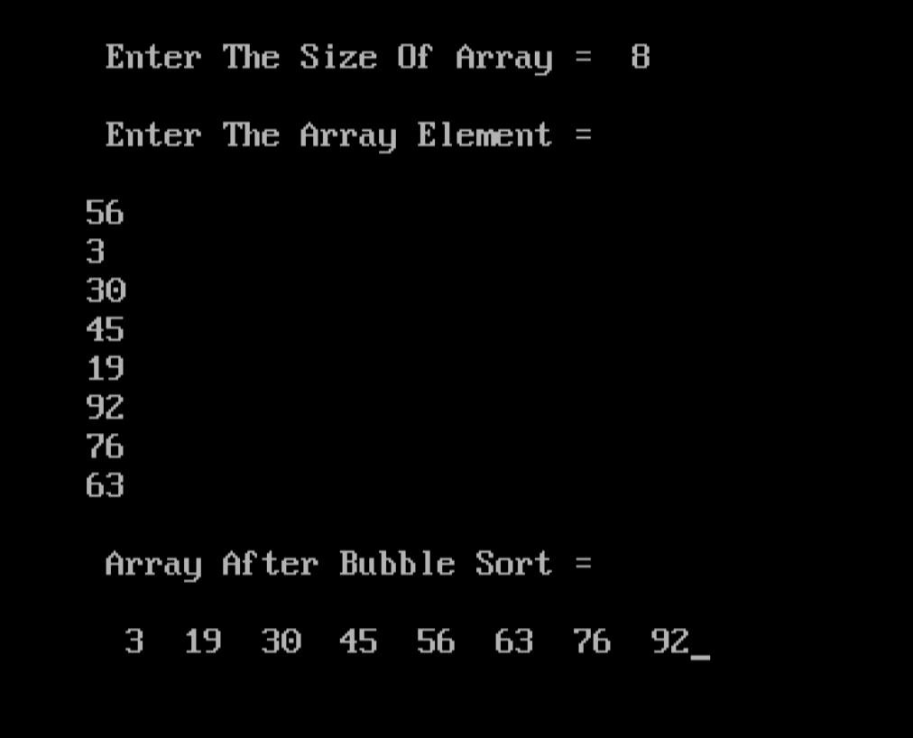

1. Insertion Sort :

#include<iostream.h>

#include<conio.h>

//using namespace std;

int main()

{

clrscr();

int a[40],i,j,p,n,temp;

cout<<"\n Enter The Number Of Elements = \n " <<endl;

for(i=0;i<8;i++)

{

cin>>a[i];

}

for(i=1;i<8;i++)

{

for(j=i;j>=1;j--)

{

if(a[j]<a[j-1])

{

temp = a[j];

a[j] = a[j-1];

a[j-1] = temp;

}

else

break;

}

}

cout<<"\n Sorted Array = \n "<<endl;

for(p=0;p<8;p++)

{

cout<<" "<<a[p];

}

getch();

return 0;

}

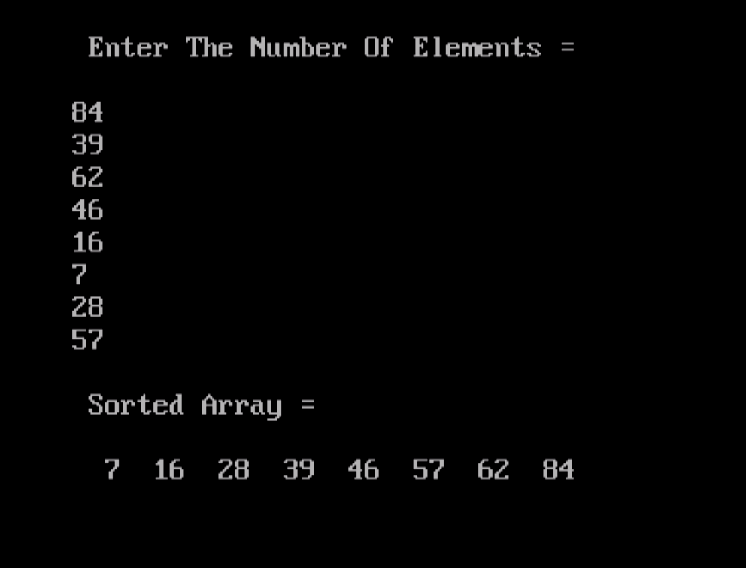

( E ) Selection Sort :

#include<iostream.h>

#include<conio.h>

//using namespace std;

int main()

{

clrscr();

int a[50],i,n,j,loca,min,temp;

cout<<"\n Enter The Number Of Elements = "<<" ";

cin>>n;

cout<<"\n Enter The Elements = \n "<<endl;

for(i=0;i<n;i++)

{

cin>>a[i];

}

for(i=0;i<n-1;i++)

{

min = a[i];

loca = i;

for(j=i+1;j<n;j++)

{

if(min>a[j])

{

min = a[j];

loca = j;

}

}

temp = a[i];

a[i] = a[loca];

a[loca] = temp;

}

cout<<"\n Sorted List Is As Follows = \n "<<endl;

for(i=0;i<n;i++)

{

cout<<" "<<a[i];

}

getch();

return 0;

}

